Lab 6

Rong Guo

C00290890

Catalog

Installing Knative Functions 3

Creating a function 4

Building, running, or deploying functions 4

Deploy the Knative service 4

Autoscaling 4

Traffic splitting 5

Knative Eventing 6

Installing Knative Functions

To install func using Homebrew

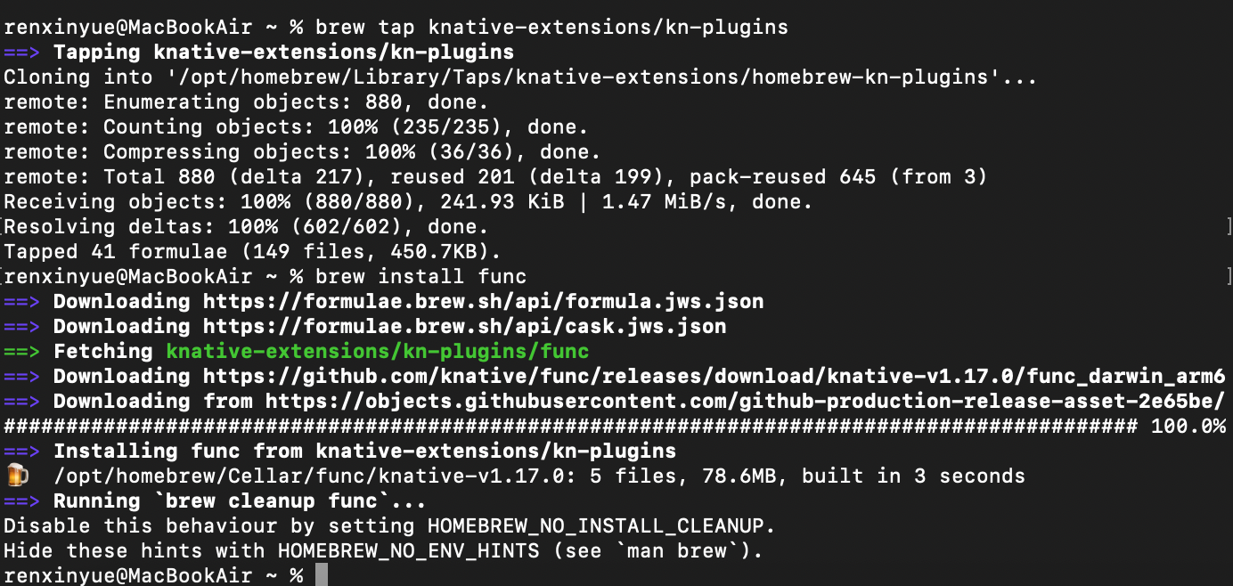

Installing the kn func CLI plugin

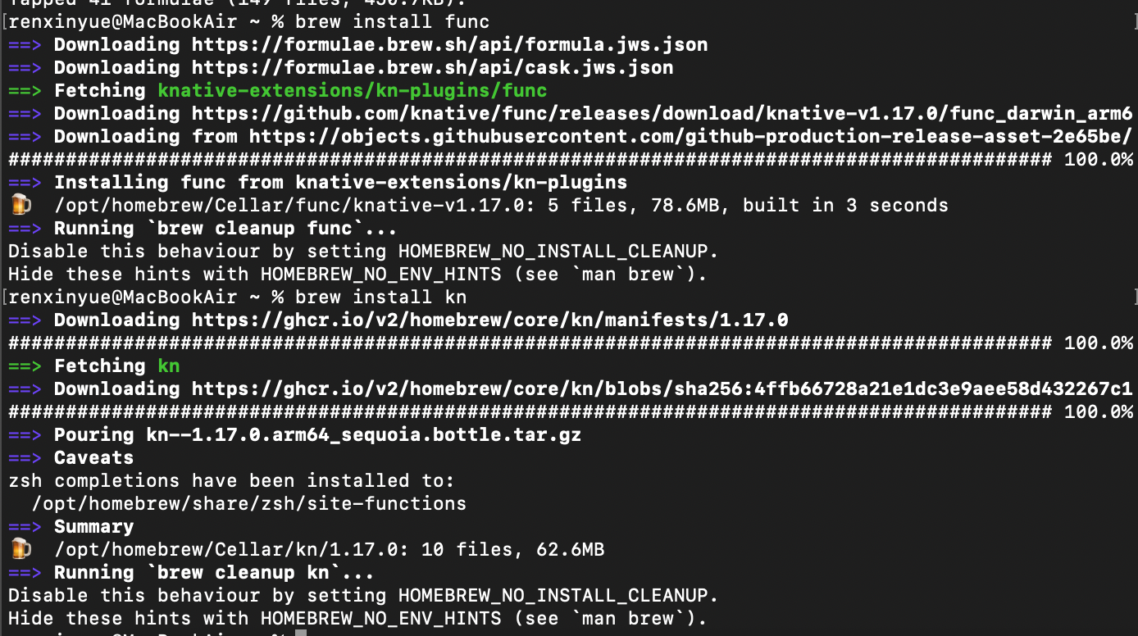

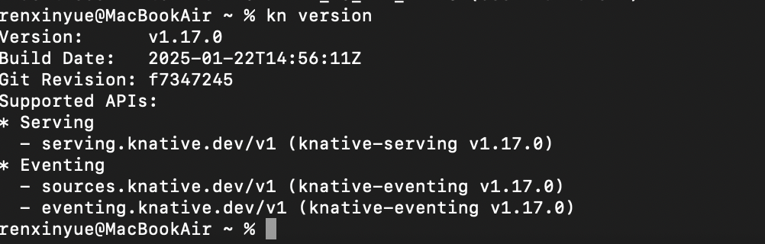

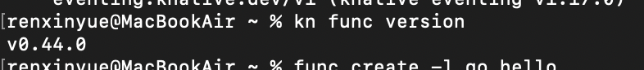

Creating a function

Create a function project by using the func CLI or the kn func plugin



Building, running, or deploying functions

Construction function

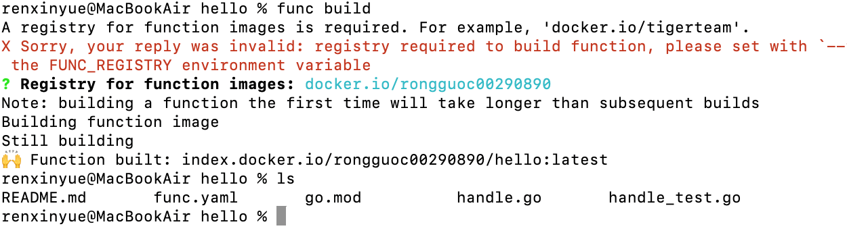

Run function

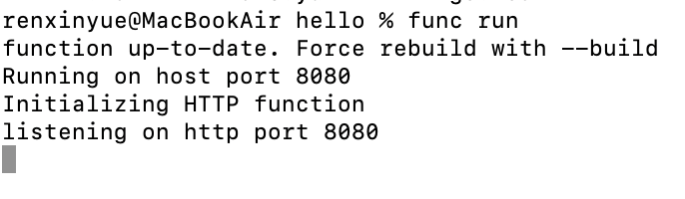

Deploy the Knative service

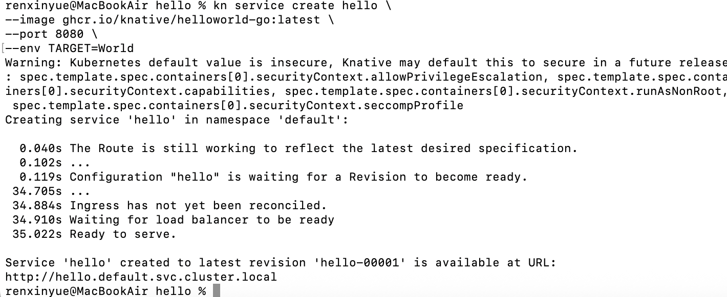

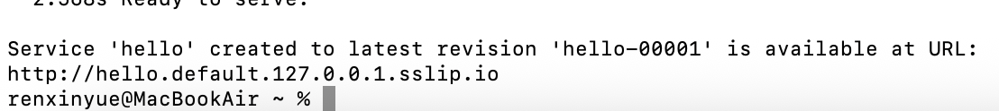

Autoscaling

View a list of Knative Services



Access your Knative Service

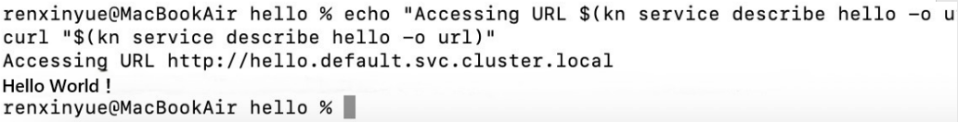

Observe autoscaling

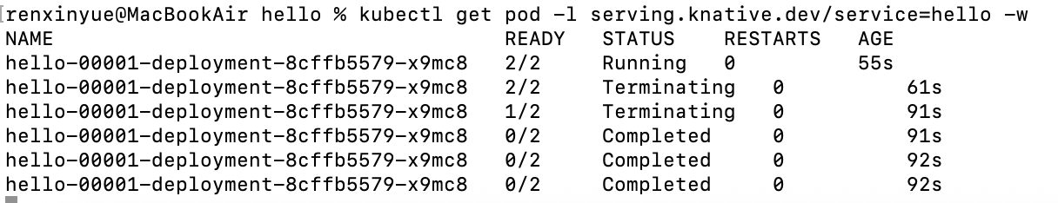

Traffic splitting

Creating a new Revision

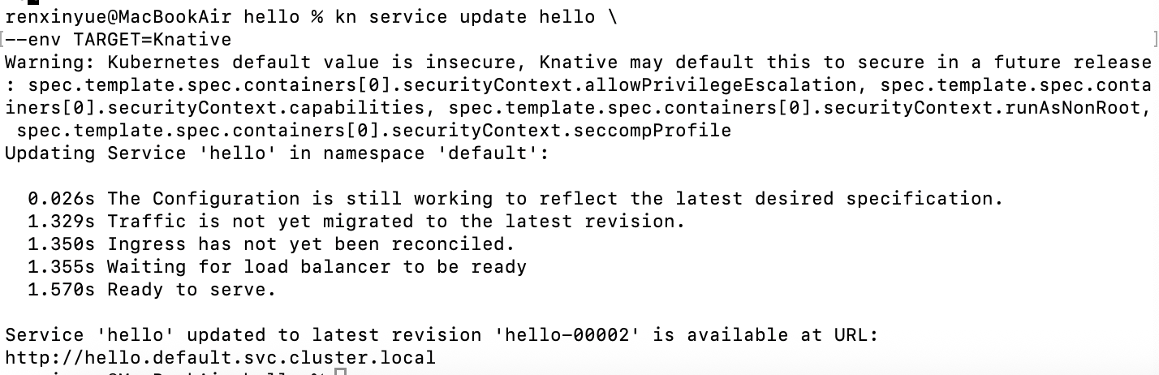

Accessing the new Revision

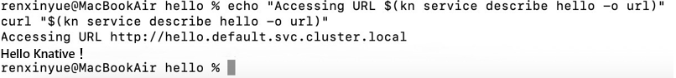

View existing Revisions

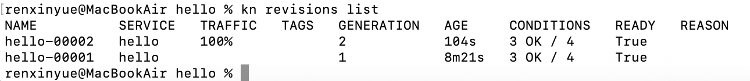

Splitting traffic between Revisions

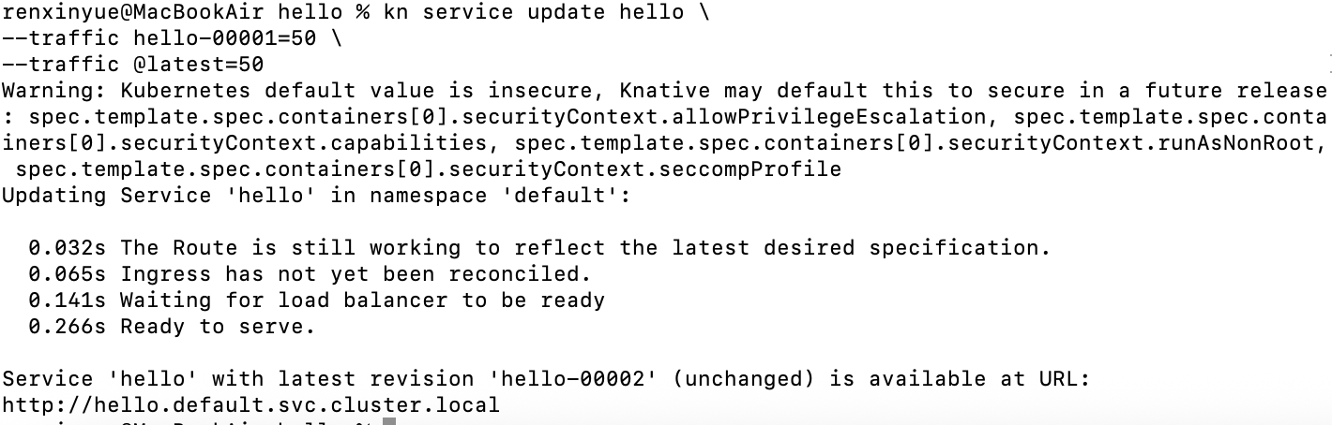

Verify the traffic split

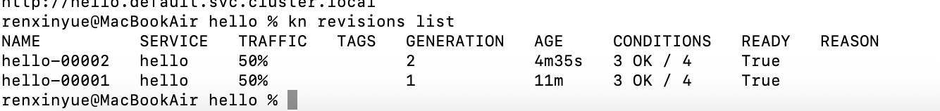

Knative Eventing

Verify that the Broker is installed

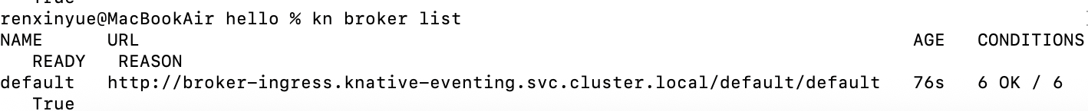

Create the CloudEvents Player Service

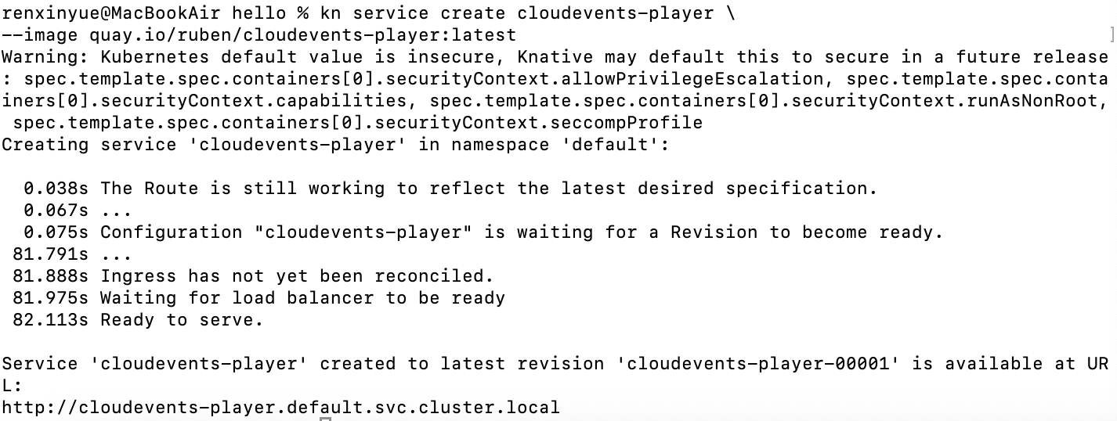

The service is now running but it doesn't know where the broker is so let's create a SinkBinding between the service and the broker.

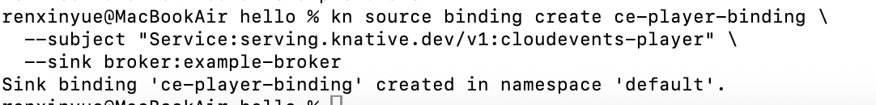

Examining the CloudEvents Player

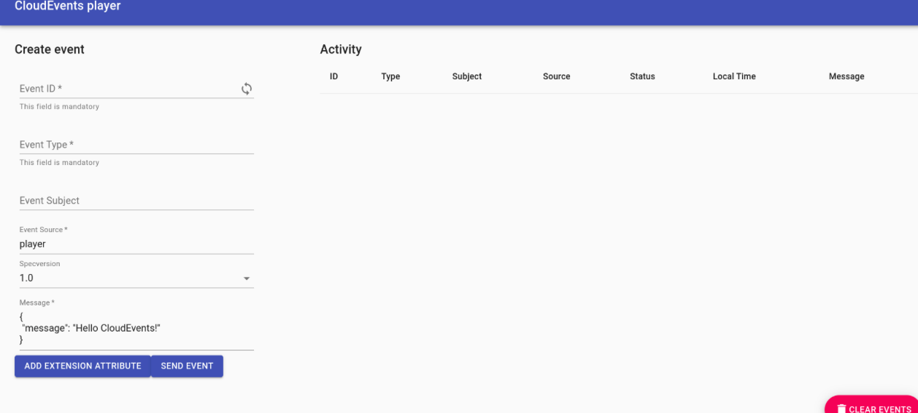

Sending an event

